Pre-Laboratory Question
- Most elements exist as components of compounds rather than in a free state. Explain why.

Most of the elements in the free state do not have a full valence shell. In a compound, they are able to complete an octet. They cannot do this in free state.

- Use colored pencils to lightly shade each element in the Periodic Table of Electronegativity Values.
Color 1 | Color 2 | Color 3 | Color 4
0 – 0.9 | 1.0 – 1.9 | 2.0 – 2.9 | 3.0 – 4.0

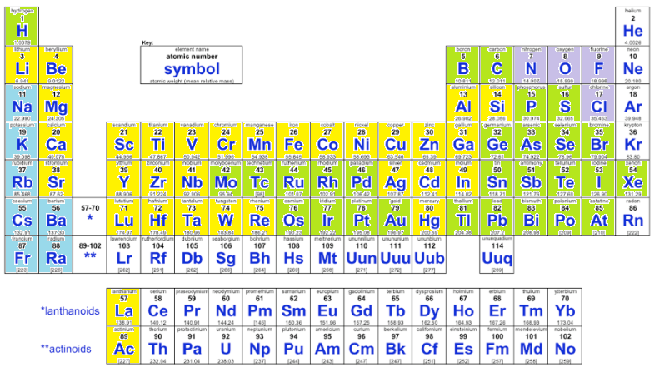

Fig: Periodic table based on electronegativity.

Laboratory Questions
- How does electronegativity influence the bond character between two elements?

The polarity of the bond is determined by the electronegativity. The difference in the electronegativity will also determine if the compound is ionic or covalent. Also, it determines which atom is the central atom in the compound.

- Describe the conditions that make covalent compounds polar.

Through the unequal sharing of electrons, covalent compounds are made polar.

- List the advantages of each type of model and the information that it provides and then list the limitations of that model.
Molecular Formula
It shows the actual makeup of the compound under focus. However, it does not describe the arrangement of the atoms in the compound. They show the same formula for different isomers of a compound.

Structural Formula
It shows how the atoms in the compound are arranged. It also shows the single, double, or other nature of the bonds in the compound. They can also be used to differentiate between isomers.

Condensed Structural Formula
It is similar to structural formula but is written in a single line. It saves space, is faster and more convenient to write. However, they do not show detailed structures existing in the compound.

Skeletal Model
It shows the skeleton of a compound made up of atoms. It is more commonly used for organic compounds. It also makes use of certain symbols to indicate sub-compounds such as Benzene in a compound. It is more difficult to draw and takes longer time. Another drawback is that it assumes and does not draw certain atoms in a compound such as Hydrogen.

Ball-and-Stick Model
It is three dimensional set up of a compound. It indicates the bonds and the atoms. It makes it much easier to visualize arrangement of atoms. It is more costly and takes a lot of time to set up.

Space-Filling Model
In this model, spheres are used to indicate an atom and space between them is used to indicate bonds. Colors are also used to indicate different models. Creating this model is also costly and time-consuming.

- Both the alkene C₄H₈ and the alkyne C₄H₆ have rigid bond structures. However, C₄H₈ can form three isomers, whereas C₄H₆ can form only two isomers. Why is this so?

The alkene has a double bond connecting the carbon atoms. This leaves room for the other four hydrogen atoms to be rearranged. On the other hand, the alkyne has only two extra hydrogen atoms.

- Are these molecules isomers? Why or why not?
 |  | 

Yes, both of these are isomers because each of these symbols has four points for the attachment of atoms.

- Which of the following molecules are geometric isomers, and which are structural isomers? Which molecule is in the trans position and which is in the cis position?
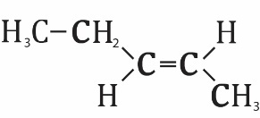 | 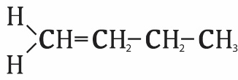 | 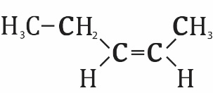

Geometric-Trans Geometric-trans

- The skeletal model of benzene is often drawn like this:
